|  |  |
| --- | --- |
|  | UNIVERSITY OF NEW HAVEN  FORENSIC SERVICES DIVISION  DIGITAL FORENSIC UNIT  ____________  300 Boston Post Road  West Haven, CT |

**REPORT OF INVESTIGATION**

**DFU CASE NO.** 12-0125 **INV. AGENCY:** BPD

**CASE ACTION:** Multiple Device Analysis

**LEAD EXAMINER:** Polletta

**LOCATION:** Channing Street, Quincy, MA

**DATE:** 12/07/25 **TIME:** 0800

**SUMMARY**

On 4/21/22, Virginia Blackburn, former fiancée of Kyle Larson, reported a break-in at her home that occurred overnight, in which her phone, some papers, and a small black desktop computer were stolen. She told police that Larson, who had recently appeared in a distressed, paranoid state, and had been staying at her home. Blacburn felt Larson was not responsible for the burglary and shared details about his troubled business relationships with Charlie Kingston and Rob Carrington. A neighbor’s Ring camera showed a vehicle resembling Charlie Kingston’s, in the area early on 4/20/22. The next day, officers stopped Kingston and located a small black computer in the front seat, papers, and gloves. After a full consented search, it was revealed that the papers found, had Blackburn’s name on them. Later that day, Blackburn found a thumb drive in an envelope in her bedroom with a note in Larson’s handwriting, instructing her to give it to the police. This resulted in a consented search. Multiple mobile devices were collected by the Boston Police Department and examined to determine the correlation between the three business partners and piece together Kyle Larson’s disappearance. All datasets were properly obtained and stored in folders where they could not be manipulated.

As the lead investigator from the Boston Police Department, I was first tasked with investigating Charlie Kingston’s Android, which the department documented and seized during a search of his vehicle. A warrant was applied for to search the suspect’s vehicle, and another to examine the devices. Upon extraction, Cellebrite was used to collect all the data relevant to the crime.

Second, I was tasked with investigating a small black Window’s computer located in the back of Kingston’s car. I documented the device and collected it, preparing it for examination. A warrant to investigate the computer was applied for and granted. To investigate the device, I uploaded the “Virginia Blackburn Windows System” file into Autopsy.

Third, I was tasked with investigating a thumb drive Blackburn had located in an envelope in her bedroom. There was a note on it from Larson saying to give it to the police when found. Blackburn provided it to us, which we documented and collected. Through a signed consent to search form, we can investigate the drive. Using Autopsy, we have the ability to examine the thumb drive.

Fourth, I was tasked with examining Charlie Kingston’s Google Data from his Samsung. Google Data included the individual’s location, any evidence related to the break-in of Virginia Blackburn’s home, and evidence of other crimes that he may be a part of. To prepare for the examination of this data, we applied for a search warrant. Through evidence found on his Samsung, we have probable cause to search through the user’s Google Data, showing possibility that he is involved with the possible disappearance of his business partner, Kyle Larson.

Last, I was tasked with investigating Rob Carrington’s iPhone to understand the users’ role in the business fraud case he is tied to with his business partners. Prior to collecting the user’s iPhone, our department documented seizing the phone from Carrington. Additionally, because of other evidence collected from various sources, there is probable cause to infer Carrington is involved in business fraud. A warrant for the iPhone examination was applied for and granted, giving the department the ability to investigate. Through Cellebrite, I uploaded the logical report, gaining access to the phone, enabling me to examine the device.

Overall, the Boston Police Department conducted a thorough, objective, and lawful investigation into the reported break-in and business fraud. Our department relied on witnesses and significant amounts of digital forensic evidence from mobile devices we collected along the way. All searches and seizures had authorized search warrants and proper chain-of-custody. Evidence was properly documented, analyzed, and preserved. At each stage, investigators followed established policies and procedures to ensure the integrity of the investigation and the protection of all involved.

**EVIDENCE**

During the examination of Charlie Kingston’s Android, I detected conversation between two individuals at separate times – “Stu” and Rob Carrington. Charlie had four contacts in his phone – Kyle Larson, Rob Carrington, “Stu” and “Support Customer.” Text communication between Charlie and Stu was detected on the morning of 4/21/22 between 9:57 am – 10:03 am. An MD5 Hash value was found on *“Text Now”* of “deef6b3bc9b3f1f3b437e1905e6aea21.”

While examining the Black Window’s Computer, I found an account linking Kyle Larson to the device, including an email [yebol21107@hmel.com](mailto:yebol21107@hmel.com) which is run as the administrator. Larson’s account was seen being used on the computer on 4/20/22 around 7:30 pm, which would be prior to the break-in. Web search history of Kyle Larson fraud investigation into his company, “CMC Care Network,” was being searched at this time.

While analyzing the Thumb Drive in Autopsy, I located a file: “thescribe.doc” created on 4/20/22 at 5:25 pm. There was a message from “The Scribe,” which is known to be Kyle Larson. For documentation purposes, the message states: “If you are reading this, there is a problem and I may be dead or worse, someone else may be dead. For many years I have been recording the notes of every meeting and phone call with Robbie and Chuck. They have screwed me at every turn. That’s what they do to everyone they come across. I know where every dollar and every body is buried. I recorded it all in ledgers that I stored secretly. They are in a safe deposit box 422 at the Regions Bank on 5th Ave in Birmingham. Leave Ginny alone. She is a good person and I always loved her. She did nothing wrong. I did. And paid the price.” Additional encryption of the thumb drive was suspected as well, due to high entropy.

Continuing, Charlie Kingston’s Android has significant amounts of Google Data related to his search history and app usage. Two searches notable to the investigation were “Rob Carrington Fraud,” and “Kyle Larson.” Both searches took place on April 13 at 8:18 am and 8:14 am. Location data was found in an Excel file on 4/20/22. At 8:29 am, Charlie was located at (42.2422905, -71.0034866), which is Quincy, MA, but appears to be downtown. Approximately 8 minutes later at 8:37 am, Charlie was located at (42.2779694, -71.0140076), also Quincy, MA, but alongside the ocean.

After the documentation and collection of Rob Carrington’s iPhone, a thorough examination using Cellebrite displayed his Apple ID: [rcarringto@gmail.com](mailto:rcarringto@gmail.com), and phone number: (205)–678-1022. Additionally, while searching through device location data, Carrington’s last know/recorded location was 4/19/22 at 11:51 am, in Pelham, Alabama, which is approximately, 5 hours and 30 minutes from the Regions Bank, where Kyle Larson has kept all the recordings from the meetings. Consistently, Carrington inquired about changing/creating a Ledger account, a record within a company that tracks all financial transactions, such as cash, accounts, or rent. MJP Sanitation is owned by Carrington, and during COVID, received $1.5 million in loans to keep 15 people employed, but the company only has 3 employees, Carrington, Kingston, and Larson. A ledger account may be used to store money given to him during COVID, as he was not using it to pay employees because there are no real employees besides the business partners. Multiple photographs and messages are shared back and forth between Carrington and an unknown number. Finally, an MD5 Hash value was found in the data: “bb18eaaabec42c911ee889fde4fa9e90a.”

**FINDINGS**

**Contacts Found in Charlie Kingston’s Android**

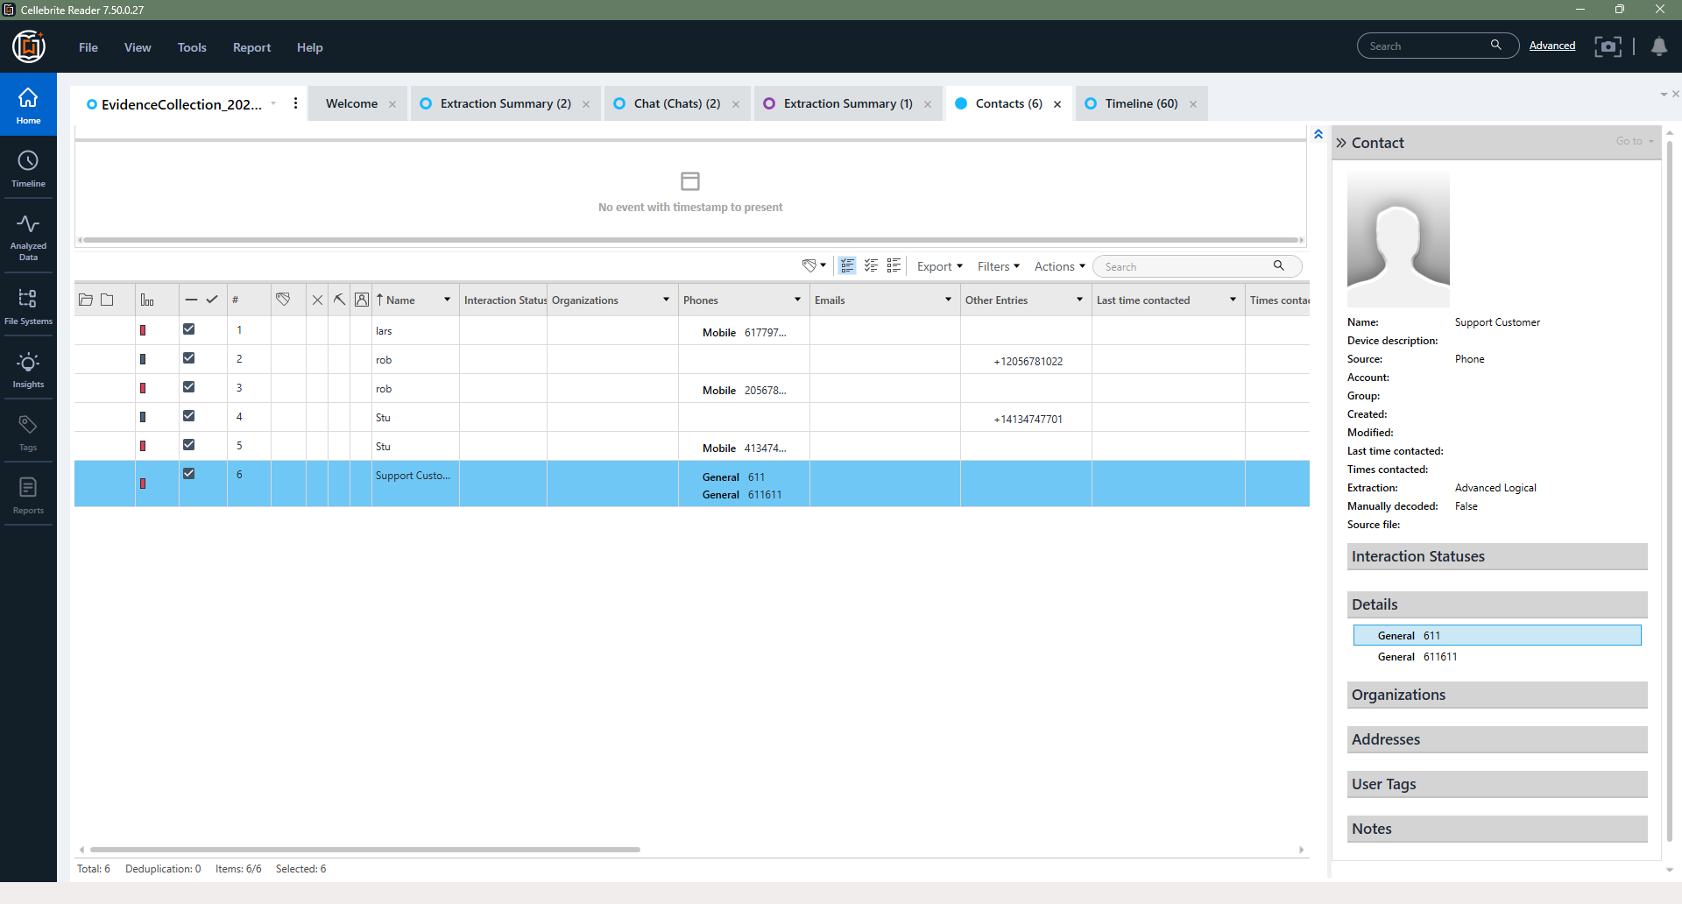

**Text Messages on Charlie Kingston’s Android**

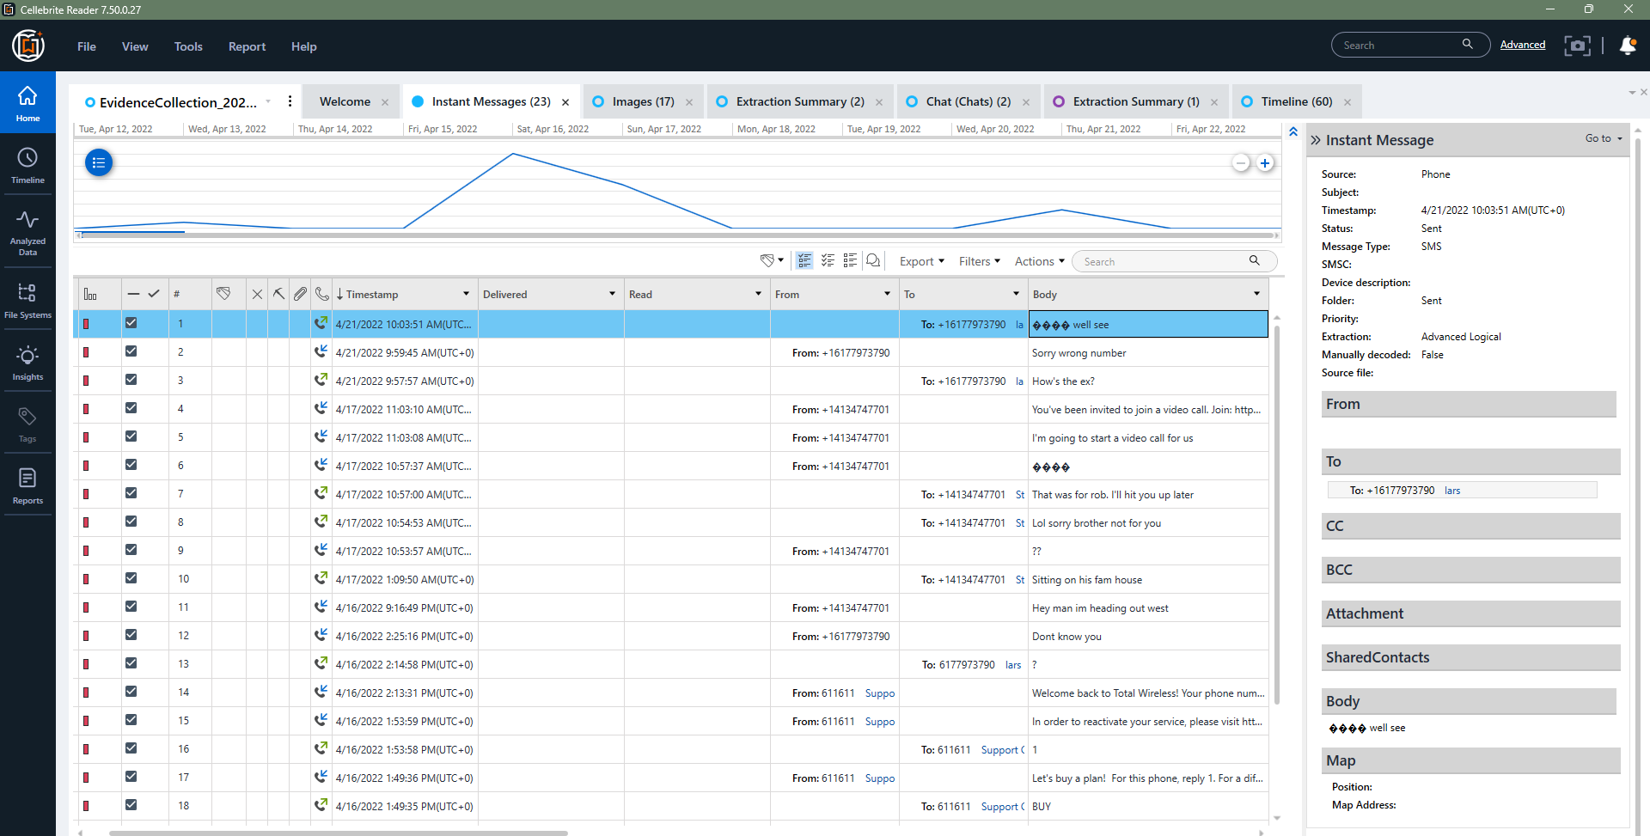

**Cellebrite Forensic Report of Charlie Kingston’s Samsung**

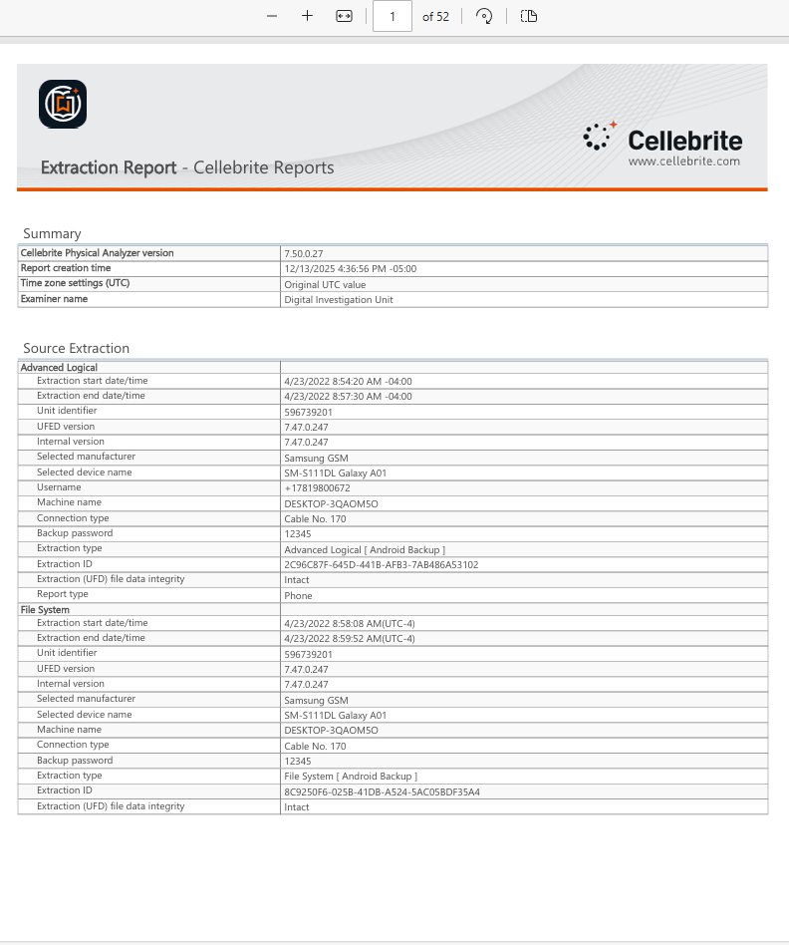

**MD5 Hash Value of *“Text Now”* Messages on the Android**

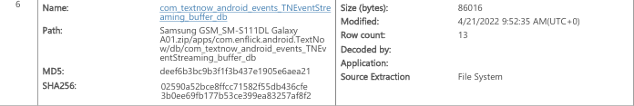

**Autopsy Forensic Report on the Black Window’s Computer**

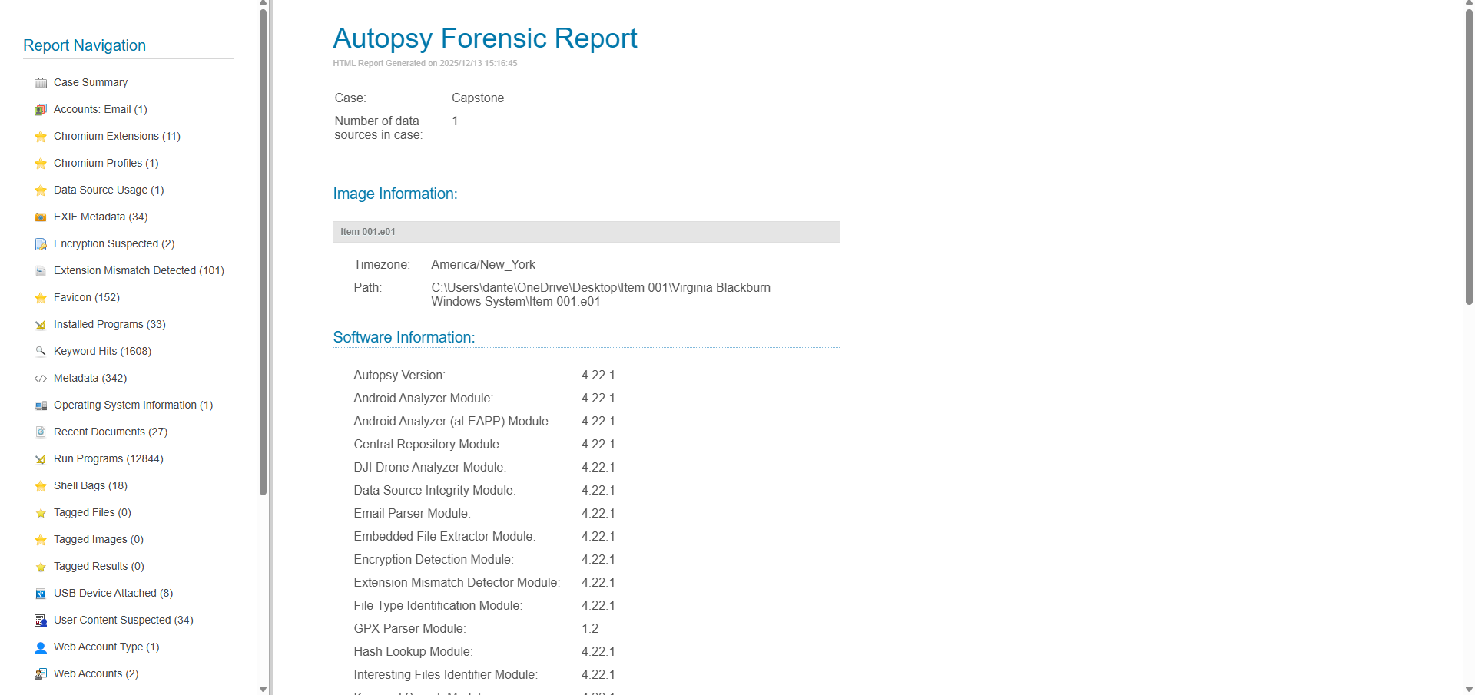

**Web Data on Autopsy Shows Account Linked to Kyle Larson**

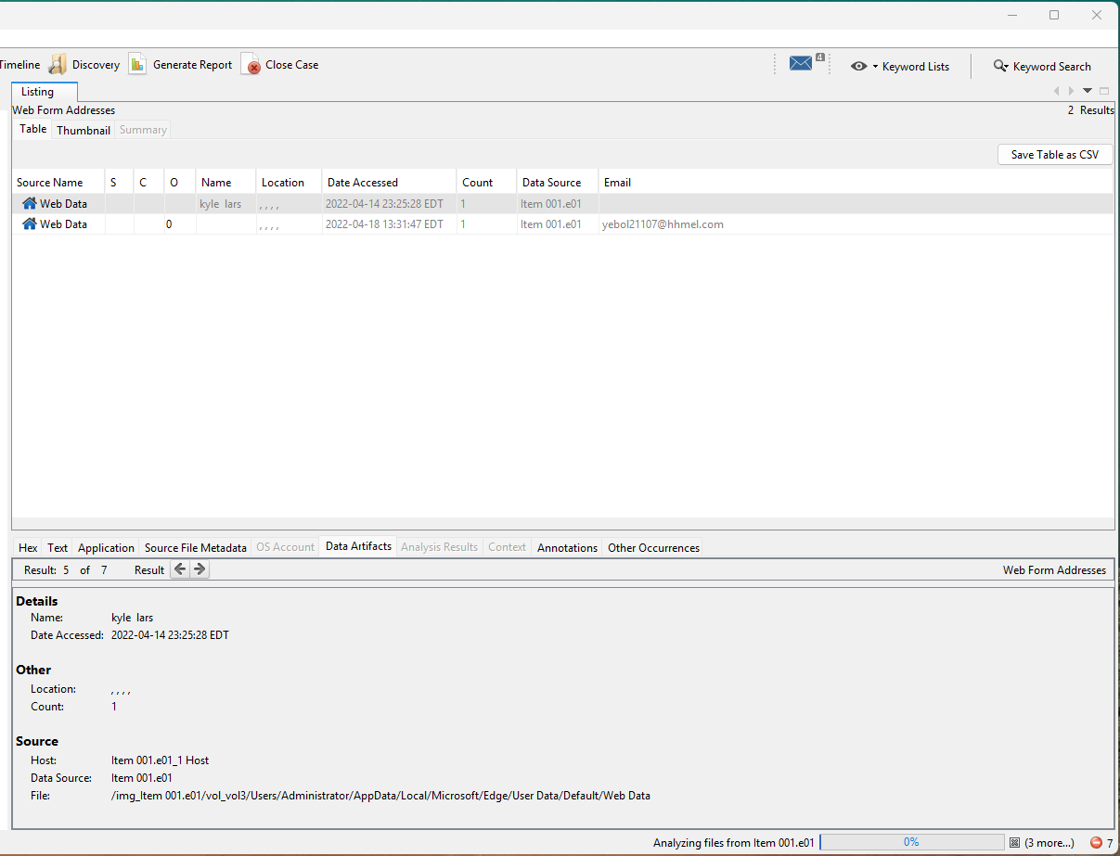

**Web Search History of Kyle Larson Business Fraud**

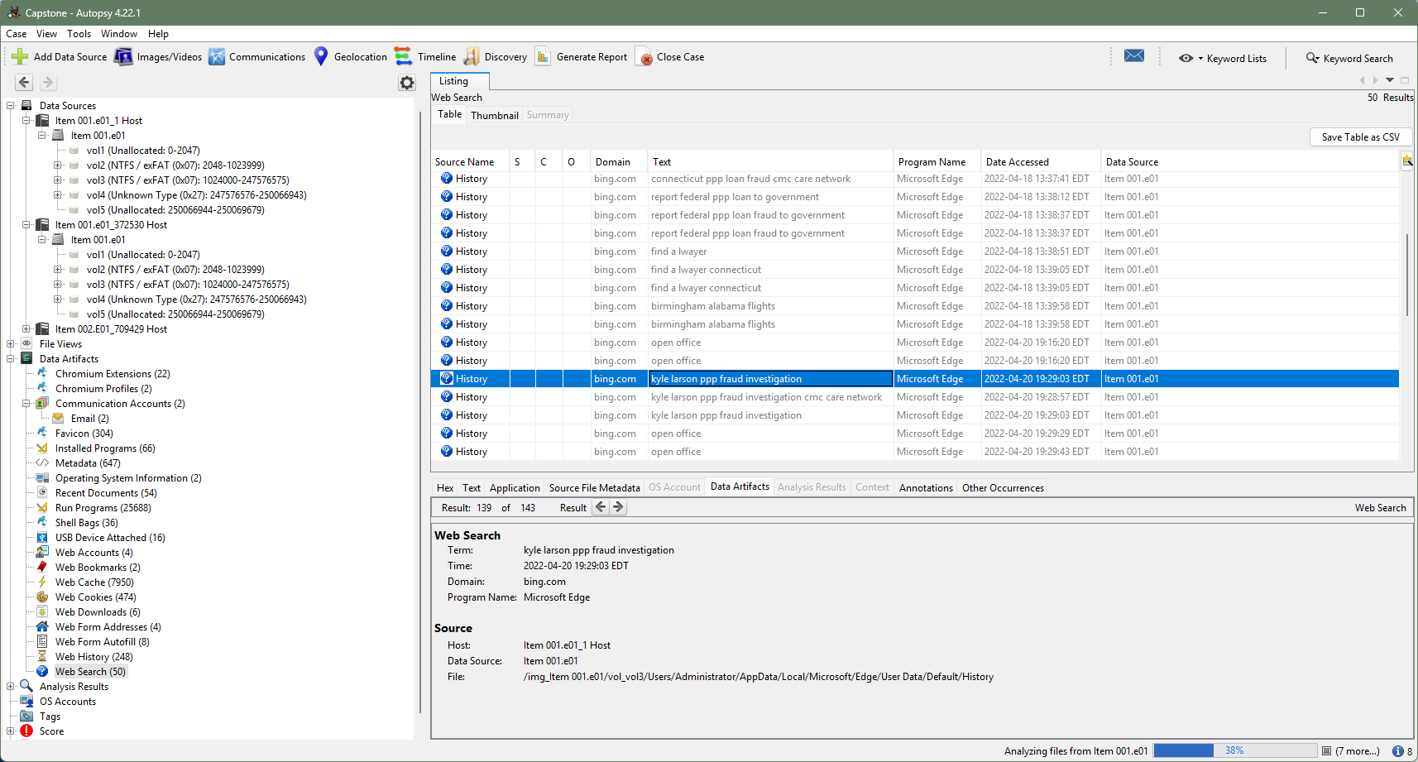

**A Message from *“The Scribe”* Found in the Thumb Drive**

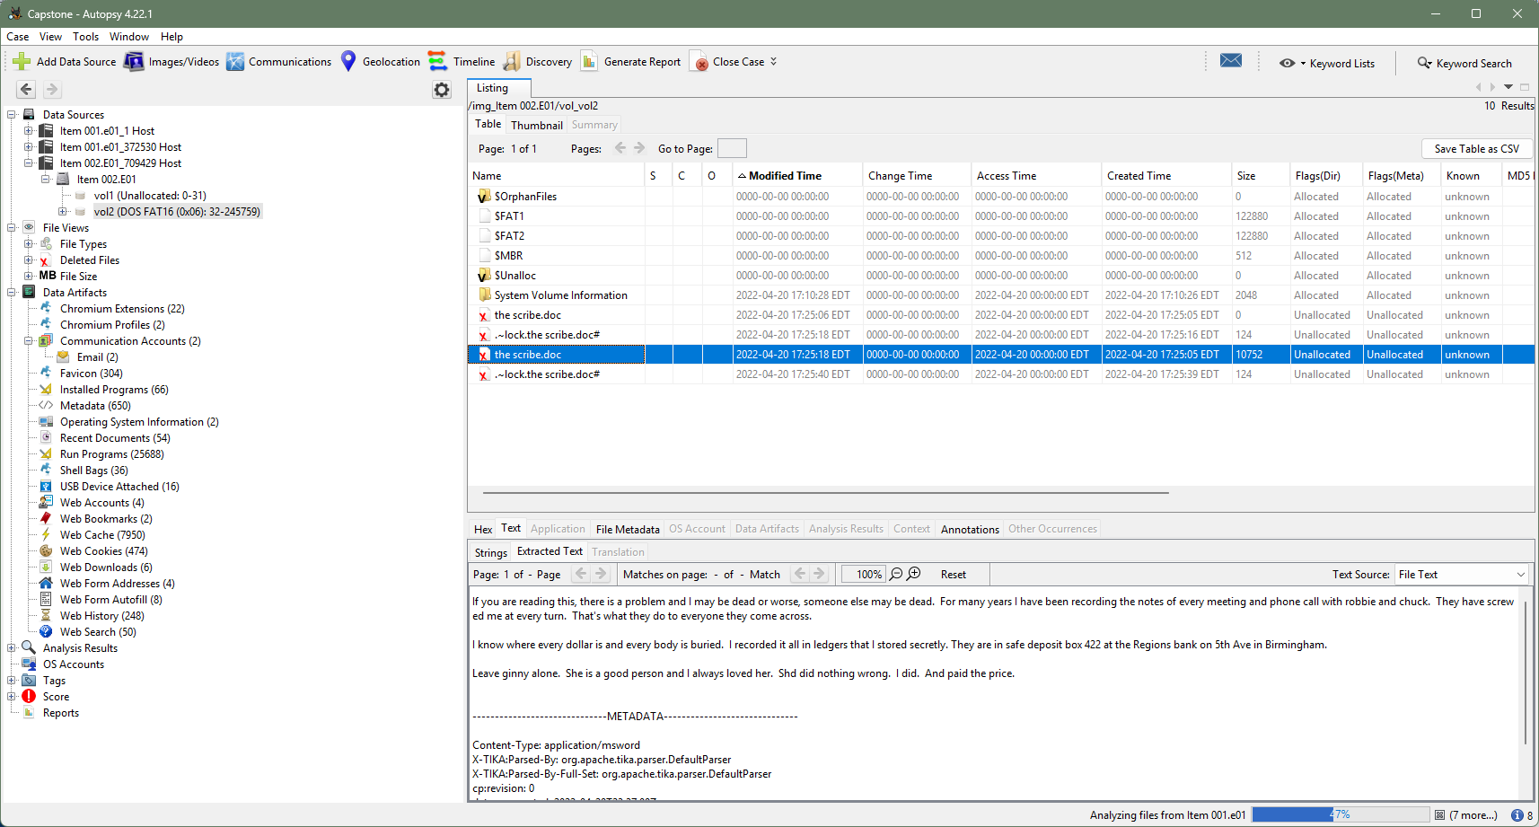

**Encryption of the Thumb Drive**

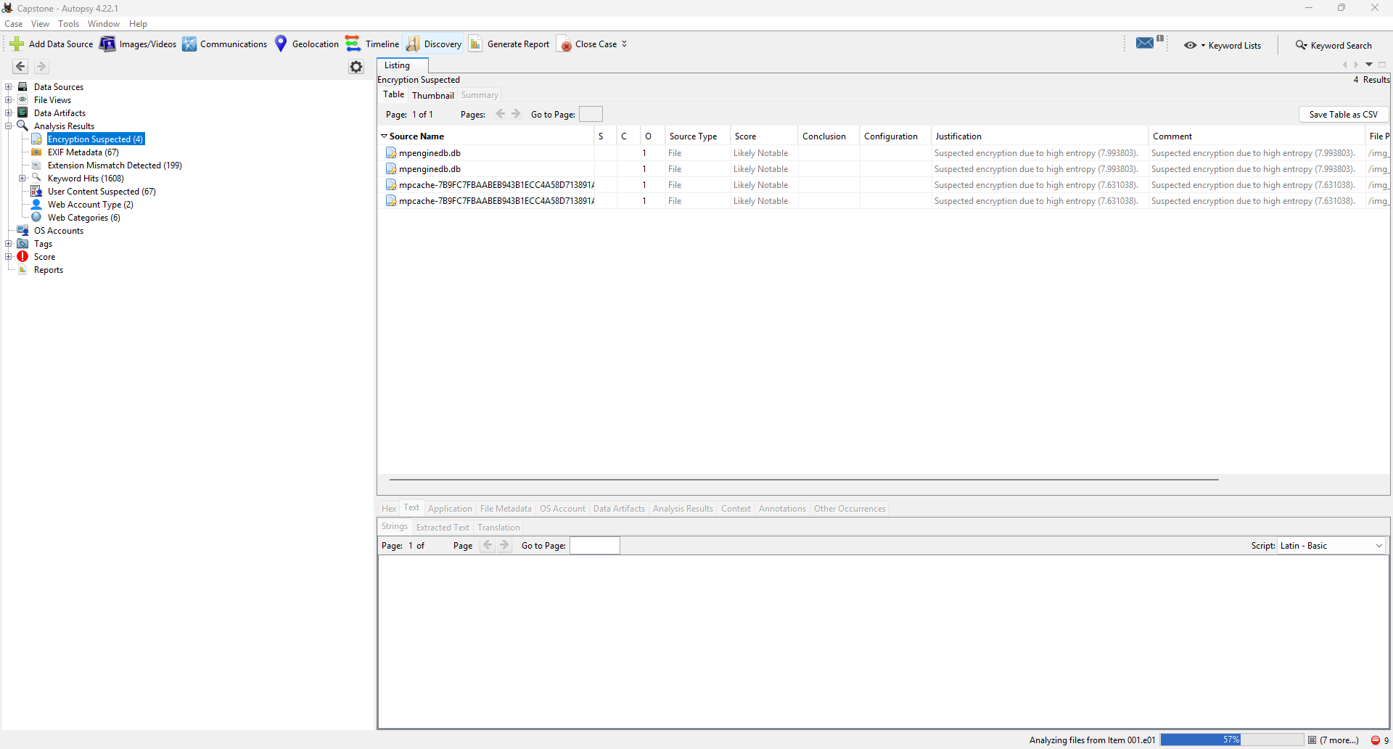

**Android Device Configuration Service Data**

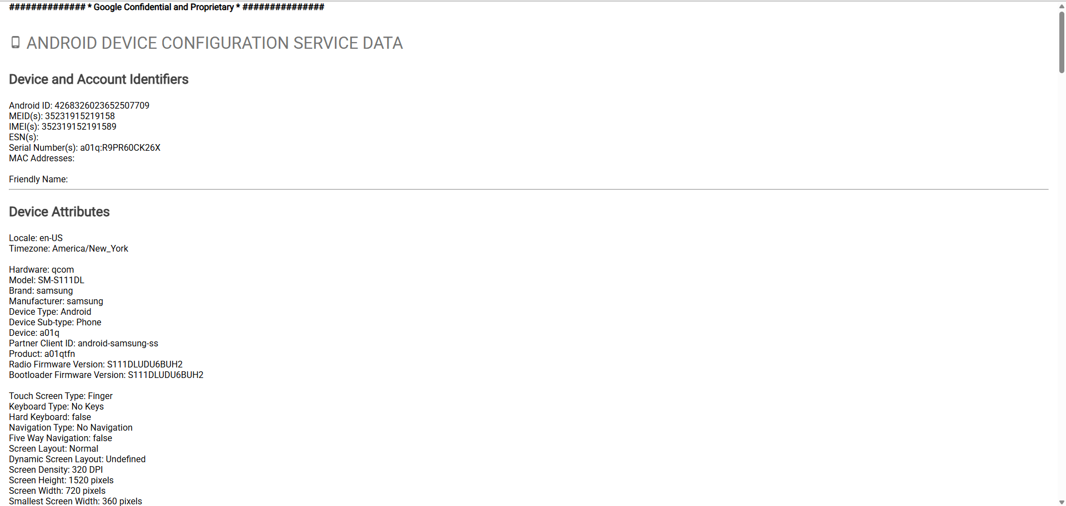

**Charlie Kingston’s Search History on Google Chrome**

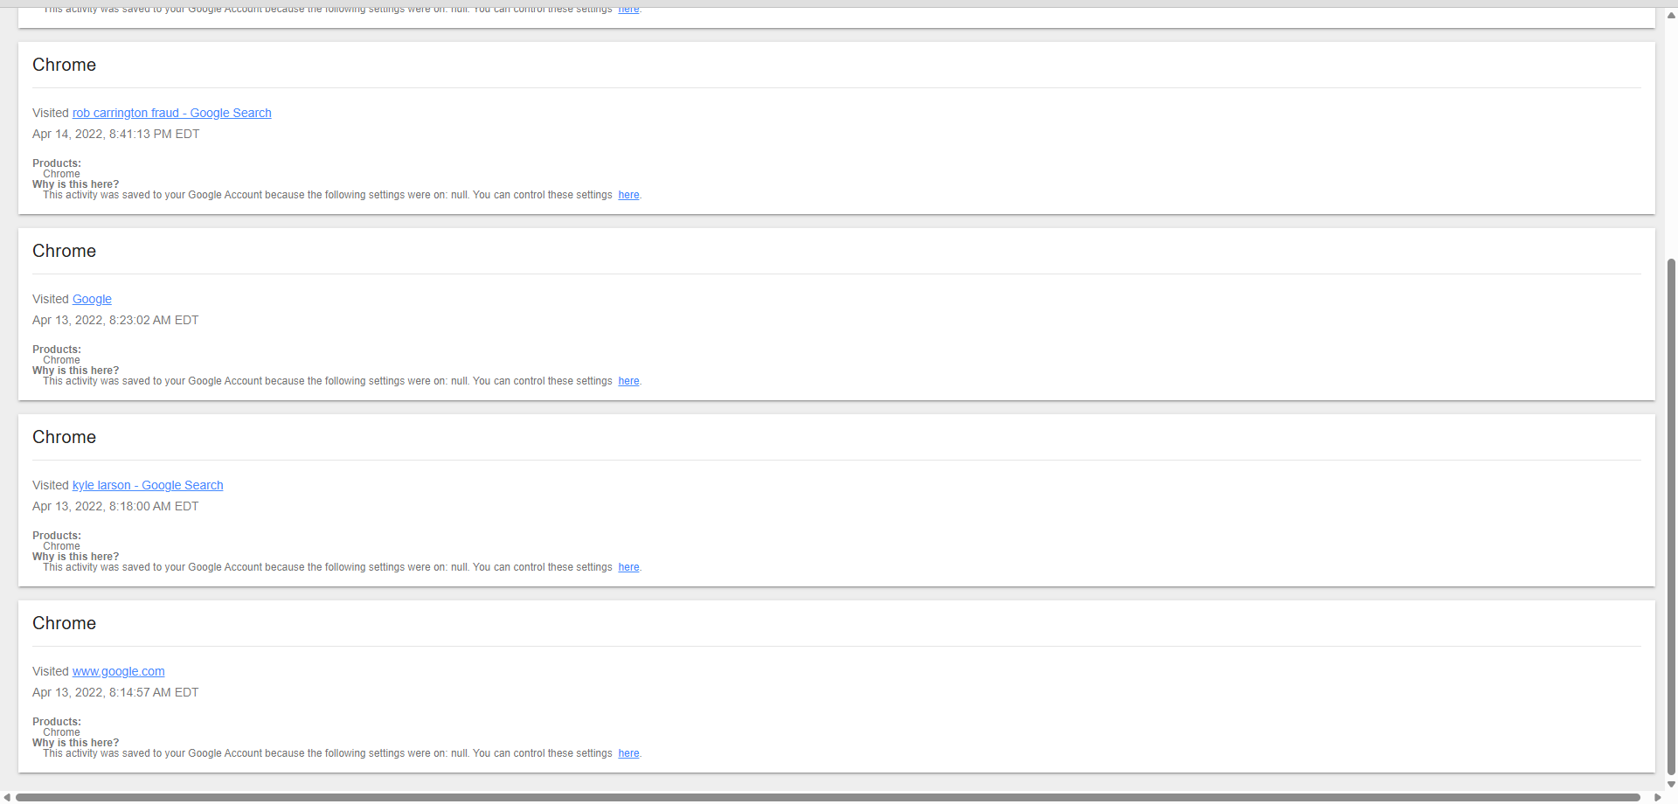

**Charlie Kingston’s Location History**

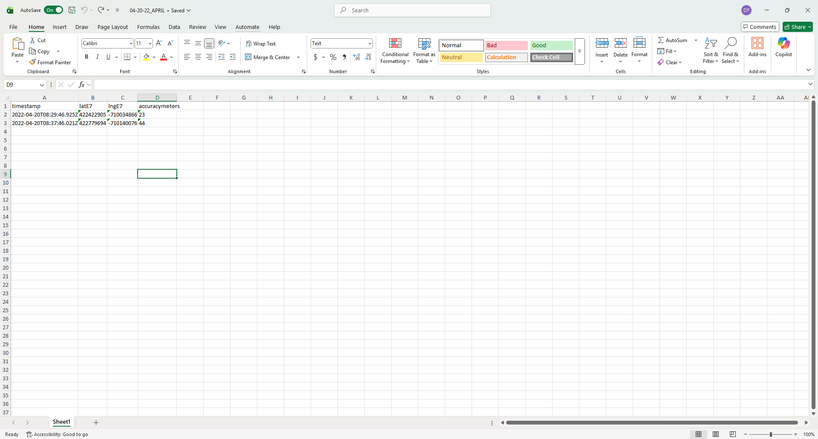

**Charlie Kingston’s Location at 8:29 am**

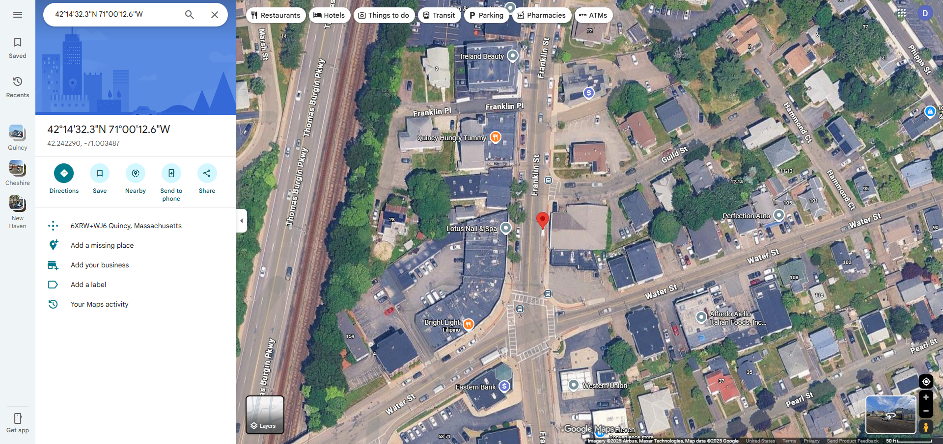

**Charlie Kingston’s Location at 8:37 am**

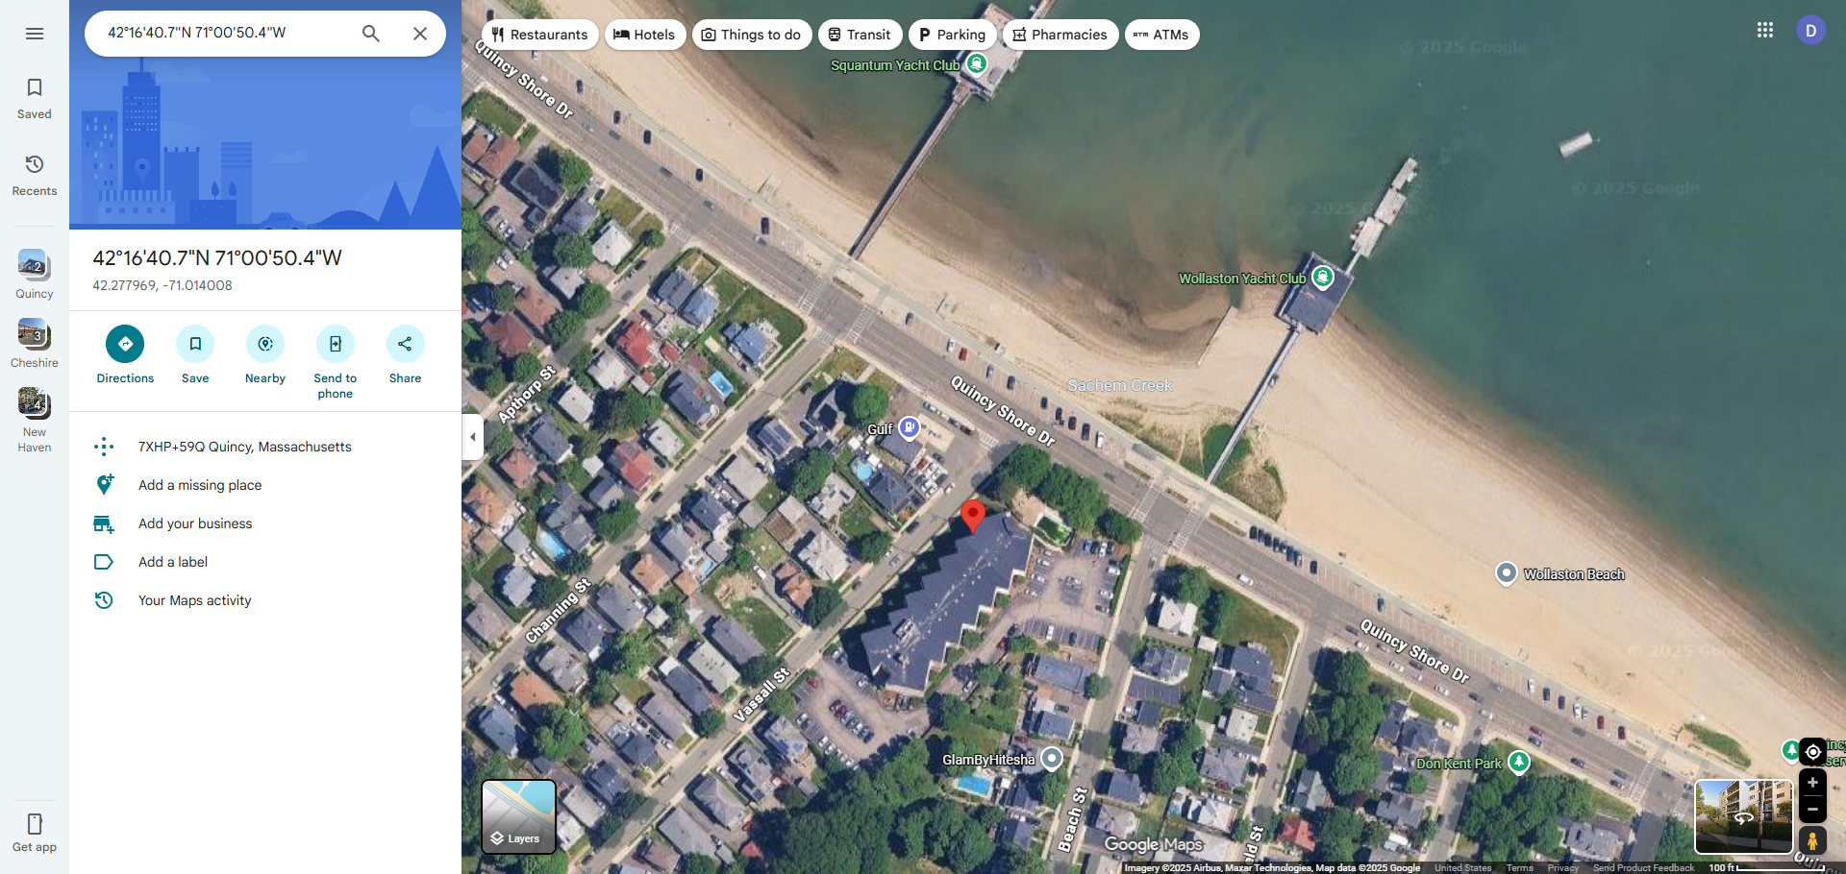

**Rob Carrington’s Last Known Location from his iPhone**

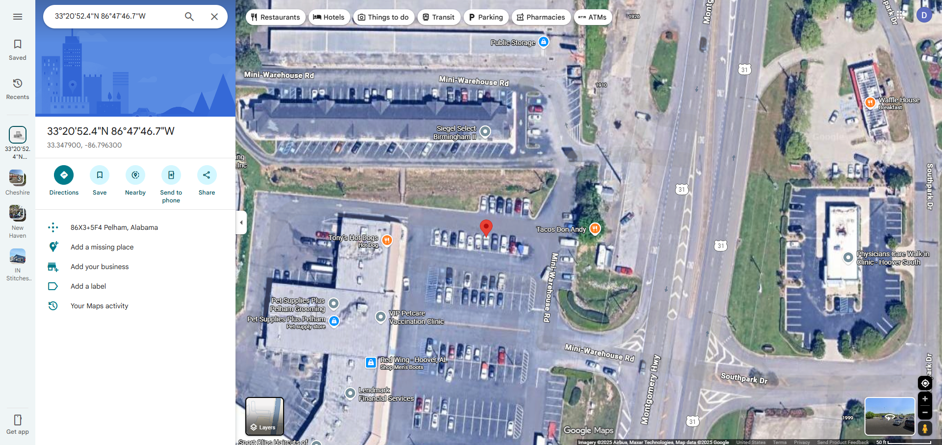

**Images from Carrington’s Phone Showing Locations of Where he Tried to get Answers on the “The Scribe”**

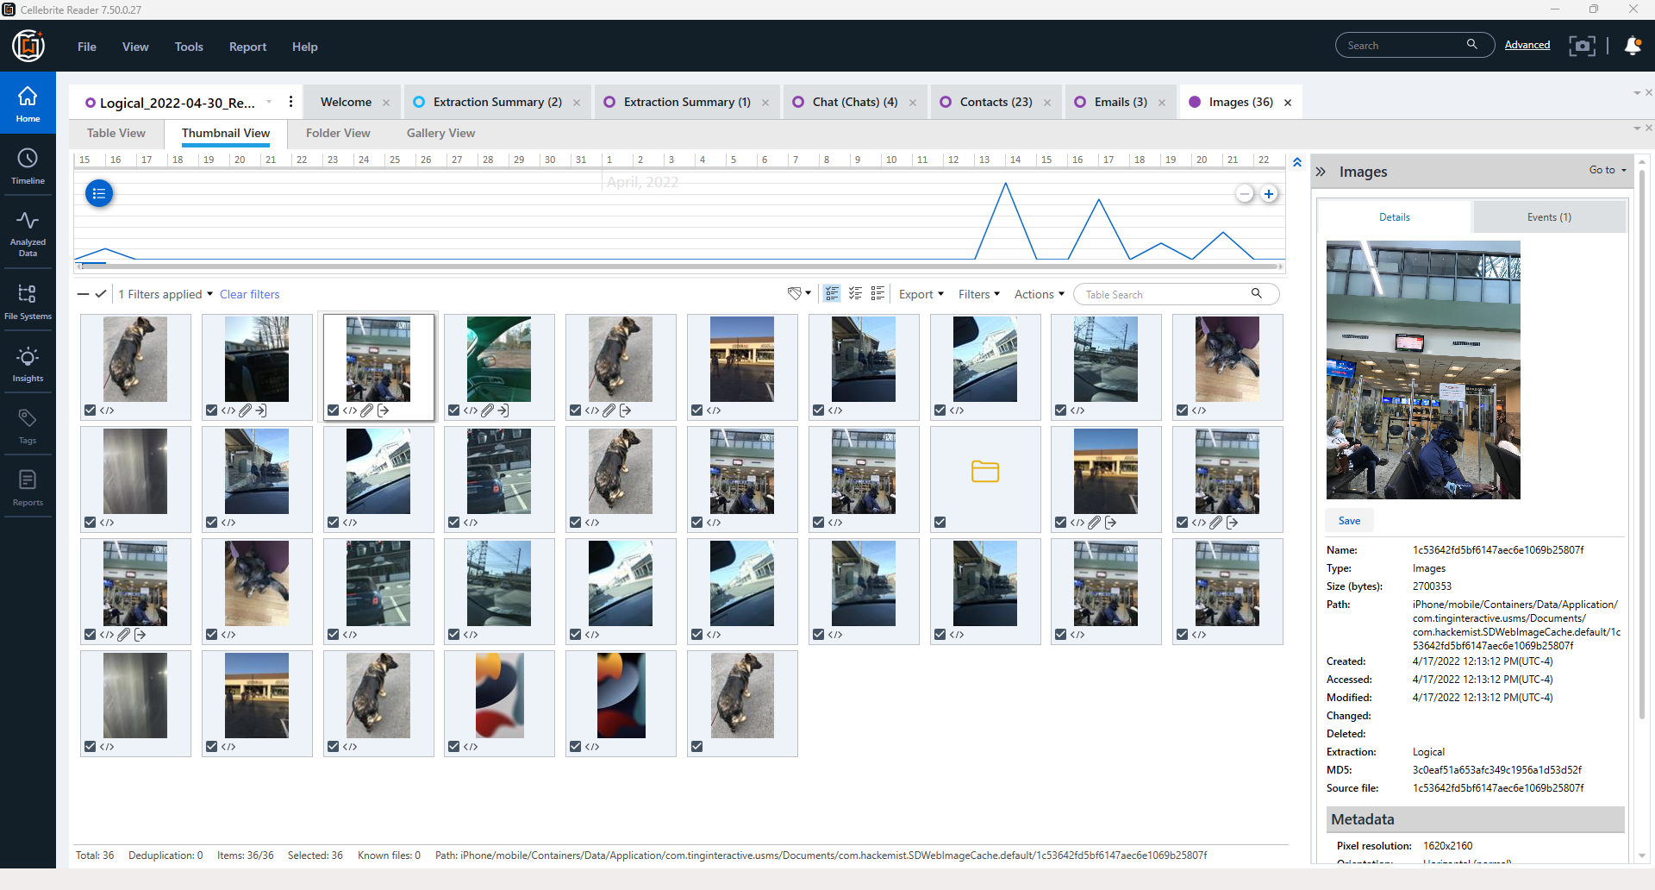

**Text Message History**

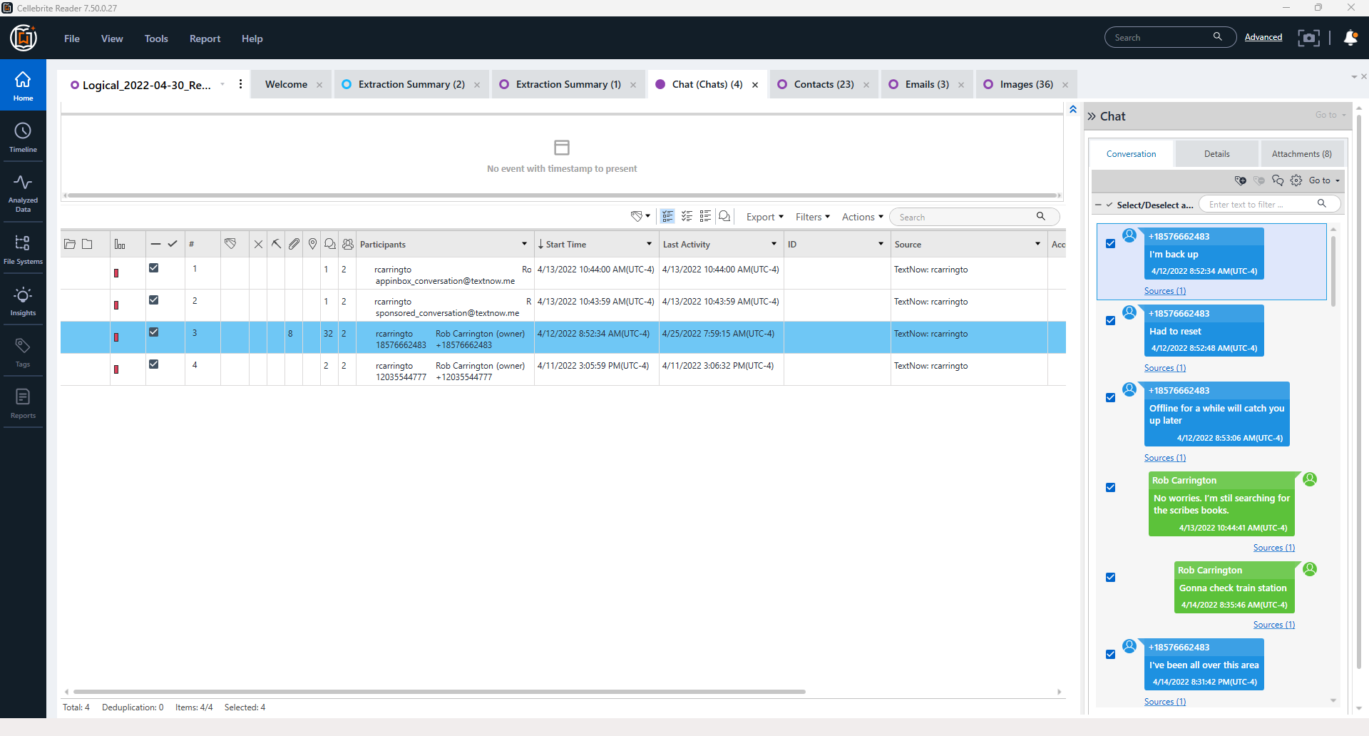

**Cellebrite Extraction Report - iPhone**

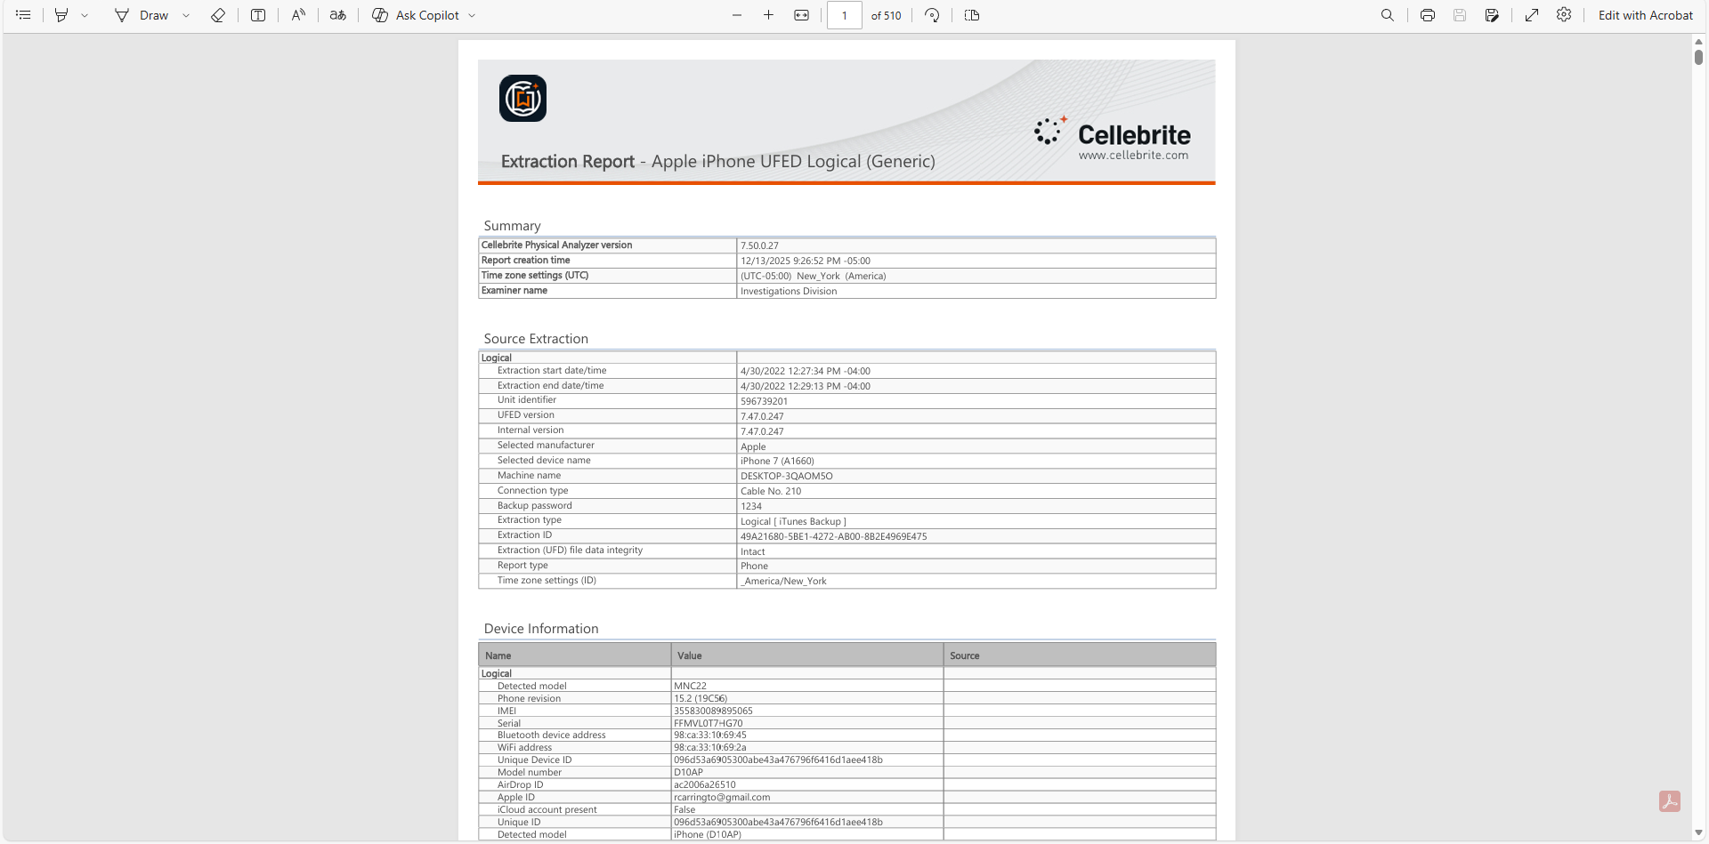

End of Report.

Respectfully Submitted,

_________________________

NAME

Dante Polletta

12/07/2025